La Case Créole as Reunionnese lieu de mémoire

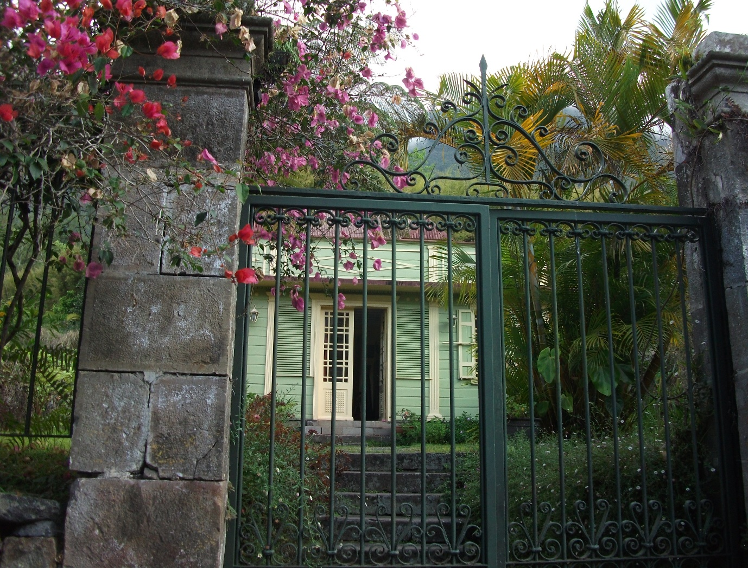
Photograph by Julia Waters
A cursory scroll through the list of ÎIe de la Réunion’s more than one hundred and fifty official monuments historiques – including over thirty disused cheminées, nearly twenty plantations or domaines, a similar number of Catholic churches, several military buildings, a scattering of statues to the island’s founding fathers (François Mahé de la Bourdonnais, Robert Corbett, Nicole Robert de la Serve), and the quarantine station for newly-arrived indentured labourers, Les Lazarets de la Grande Chaloupe – reads like so many physical vestiges of often brutal and exploitative history of France’s remote, Indian Ocean département. In addition to the many public buildings classified as monuments historiques - physical manifestations of France’s imperial power - there are also more than twenty maisons or villas: for the most part, the former residences of Reunion’s colonial administrators and plantation owners. Such a listing, compiled by France’s Ministère de la Culture et de la Communication, both preserves and consecrates the historically important places and people of Reunion’s past. As such, it constitutes an official, state-sanctioned roll-call of what Nora calls the ‘dominant’ lieux de mémoire of the former French colony. In this context, it is revealing to note the use of the standard French terms maison and villa to describe domestic dwellings which would in Reunion most commonly be known as cases - a linguistic move which, arguably, appropriates as ‘French’ what are, in fact, examples of a distinctive, local architectural form.
Contrary to its more common Caribbean usage (as, most notably, in the term ‘cases-nègres’) or to standard French dictionary definitions, the Reunionnese term case does not denote “des paillottes et des huttes, de pays tropicaux ou exotiques”’ (Barat 1993, 13). Although Reunionnese vernacular architecture, and hence its terminology, certainly has its origins in such basic shelters, improvised from the raw, natural materials of the island, the term ‘case’ has developed locally over time to encompass dwellings of very different sizes and social standings: from the humble ‘cases bois sous tôle’, ‘case béton sous tôle’ or even ‘case tôle sous tôle’ of former slaves and of the most impoverished sections of society, to the imposing ‘grand’ cases’ of the planteur and administrative elites. In contrast to the often one-sided (French) historical significance of many ‘dominant’ historic monuments, the often modest, vernacular case créole embodies, as Asselin and Hennequet (2001, 7) note, ‘une architecture originale influencée par les conditions géographiques et la diversité des peuplements.’ They continue:
Ici le génie des lieux pare les formes venues d’Europe, et d’ailleurs, d’accents singuliers qui concentrent dans l’espace familier de la maison traditionnelle les symboles de la culture créole réunionnaise. Maison des racines, l’habitat traditionnel conserve jalousement trois siècles de mémoire de l’île.

It is the ‘dominated’ lieu de mémoire of the case créole, as physical ‘crystallisation’ of the various stages of Reunion’s history - from trading post, to pioneer settlement, to thriving plantation colony, to département d’outre-mer – and as potent symbol of a lost ‘art de vivre réunionnais’, that will be the focus of this chapter. Recent studies of Reunion’s vernacular architecture repeatedly stress, with nostalgic regret, the seemingly ineluctable disappearance of the case créole - at least as a living, lived-in milieu. Nonetheless, in a final part, this chapter will consider recent developments which, somewhat paradoxically, signal the enduring resilience and adaptability of this most evocative of (neo)colonial lieux de mémoire.
Any visitor to Reunion will have been struck by the ostentatious, brilliant white façades of the grand’ cases glimpsed through their ornate grilles and barreaux on St. Denis’s main avenues, and by the exuberant splashes of vivid colour that draw the eye to the tiniest case bois sous tôle deep in the island’s verdant, mountainous interior. There are estimated to be between 5,000 and 7,000 cases créoles, large and small, scattered across the 2,512 km² of the island’s territory, encompassing both urban and rural areas, and extending from the densely-populated coastal plains (les Bas), to the remotest heights of its interior (les Hauts). If marked on a map of Reunion, the geographical distribution of these traditional dwellings would indicate the locations of the oldest settlements and the original centres of towns and villages, so serving as a revealing palimpsest of the historic patterns of conquest, settlement and development of the island. Yet, despite their number and their undeniable aesthetic charm, the traditional cases créoles are in danger – from cyclones, from termites, from urban development and, until recently at least, from the lack of recognition, by the local population, of their value as physical manifestations of a rich ‘patrimoine culturel multiple et métissé’.
Despite their superficial diversity of size, colour and decoration, Reunion’s cases créoles in fact adhere, with remarkable consistency, to the same set of abiding architectural principles – especially, symmetry, order, and the controlled relationship between domestic interior and natural exterior – that evolved over three centuries of colonial rule. Indeed, many of these architectural principles were formally dictated, in the eighteenth century, by the Compagnie Française des Indes, keen to impose order on the island’s unruly multi-ethnic population and on its wild, often inhospitable terrain.
The traditional case créole’s defining rectangular shape, high roof, and use of local woods and vegetable matter as building materials can all be traced back to the very earliest shelters, constructed by the first French pioneer-settlers – or, more accurately, by the slaves who were brought with them - in the late seventeenth century. With no indigenous dwellings to act as models, these early, largely improvised shelters - that Jonquères d’Oriola (2001, 13) describes as ‘une architecture élémentaire issue des besoins immédiats’ - drew their inspiration from the traditional cases of the Tanosy region of southern Madagascar, from where these first slaves originated. In her novel, L’Aïeule de l’Isle Bourbon, which tells the story of one of the very first female pioneer-settlers, Monique Agénor (1993, 103) describes their rudimentary cases as ‘des petites cabanes en bois de bambou, aux toits de latanier, et au sol de terre battue.’ Throughout her narrative, the development of the island’s society is mirrored in the evolution of their dwellings – a theme that can be found in much Reunionnese literature.
During the eighteenth century, and with the introduction of coffee to Île Bourbon, large numbers of Breton sailors and craftsmen were lured to the island by the Compagnie Française des Indes’ offer of plots of agricultural land. The model of case that developed during this period maintained the earlier rectangular form and use of native plant materials, but was constructed on an open wooden frame, strengthened by supporting cross-beams, and panelled with walls of wooden planks or bardeaux (wooden shingles) – a model which was influenced by the vernacular architecture of the new settlers’ native Brittany, combined with their own boat-building and carpentry techniques. From early on, the use of brick and stone, which required skills, tools and raw materials that were hard to find on the island, was reserved for public buildings, symbolic of European colonial power, and for only the most ostentatious and extravagant of private houses.
In the late eighteenth century, the seemingly far-off trauma of the French Revolution would also have a profound and enduring influence on the development of Reunion’s vernacular architecture. Fleeing the Terror, aristocratic families sought refuge on the island (thenceforth renamed the more egalitarian ‘Île de la Réunion’ by the post-revolutionary powers), bringing with them the taste for neoclassical architecture that was fashionable across Europe at the time. Again, building on and adapting the pre-existing, rectangular, wooden-framed structure, the neoclassical ideals - of symmetry, pure lines and balance, with all elements arranged around a central axis - thenceforth became abiding architectural norms for Reunion’s cases créoles. It was also during this period that another ‘incontournable’ of more affluent créole domestic architecture was introduced – the veranda or varangue – imported, along with spices, textiles, furniture and craftsmen, from the French, but formerly Portuguese, comptoir of Pondichery. Thenceforth, as Hennequet (2001, 96) comments:
Le temps s’est arrêté et cette disposition sur un axe […] se lira quasiment partout autour de l’île, de villes en villages jusque dans les propriétés rurales les plus reculées. Cette symétrie est la signature plus ou moins marquée de la topologie des grandes maisons et de leurs plus petites cadettes.

While the underlying principles of Reunionnese domestic architecture were thus firmly in place by the end of the eighteenth century, it was during the nineteenth century that the more flamboyant, decorative elements of what now constitutes typical creole domestic architecture were first introduced. The fashion for decorative embellishment was made possible at this time by Reunion’s increased prosperity when, following the Haitian Revolution and ensuing upheaval in the Caribbean, the colonial administration seized the opportunity to establish Reunion as France’s new sugar island, developing a network of large-scale plantations and exploiting slave and, later, indentured labour. Typical decorative features introduced during this period of sugar-fuelled prosperity, include the use, on smaller cases, of vibrantly coloured external paintwork, arguably reflecting the African or Indian origins of their occupants, as well as the vivid colours of local flora; the addition, in grander cases of a pavilion or guétali atop the front garden wall, a feature borrowed from Indian gardens; and the use of lambrequins – delicate, wooden or tin-work decorative borders, in the form of stylised flowers, vines and leaves, that adorn the edges of roofs and canopies, and which had precursors in the Indian provinces of Gujarat and Pondichery.
While all of these now characteristic, imported features have evident aesthetic appeal, they are, as always, also functional. The canopied guétali (Reunionnese Creole for ‘regarde-là’) allowed the household to participate in the activity of the street, while remaining sheltered from the sun. The lambrequins, together with often flamboyant guttering and downpipes, help to catch and channel rainwater. Decorative window-frames, columns, borders and cornices, like external paintwork, all protect the wooden buildings from rain and insects. This mixture of the aesthetic and the practical is typical of the ways in which, during Reunion’s three centuries as the trading post of colonial France on the Routes des Indes, the case créole incorporated imported models, features and techniques – including from Madagascar, Portuguese and French India, rural Brittany and aristocratic, pre-revolutionary France - and adapted them to the particular local needs and conditions of the remote Indian Ocean island. The case créole thus crystallises, in physical form, the accumulative series of events, inter-cultural connections and socio-economic developments that have shaped Reunion’s history.
In addition, the lay-out and design of the case créole also reflect – and are a product of - a particular ‘mode d’habiter créole’ that endured throughout the colonial era but which still lives on today in the memory, rather than the practice, of older members of Reunionnese society. With the case positioned firmly in the centre of its plot, the arrangement of internal and external spaces, and of front and rear gardens (emplacement and cour) mirrors a highly formalised relation between public and private, social and intimate spheres, that is encapsulated in the following description by architectural historian Christian Barat (1993, 84):
Petite ou grande, rurale ou urbaine, la villa créole est un ‘théâtre de haute tradition’ dont la hiérarchie des fonctions, hors et dans le bâtiment, est constant. Depuis la rue, à travers le jardin, la demeure et la cour arrière, plusieurs étapes transitoires expriment, suivant un axe central, la progression du plus social au plus privé: le barreau, l’allée dallée du jardin, la varangue, le salon, la salle à manger, et de nouveau une varangue pour déboucher sur la cour domestique cernée de dépendances.

With the property’s arrangement dictated by its neoclassical symmetry, the front (l’avant) is the social, public space, open onto the road, and is maintained with rigorous care. It is here, on the varangue, that guests and outsiders were received. In contrast, the area at the rear of the property – ‘l’arrière’ – is a more informal, private and disordered space, which traditionally includes an external kitchen (boucan), animal pens, laundry and other out-buildings, arranged around a shady cour. This is where the untidy business of daily life was conducted and where close friends and family socialised. The inter-relation between physical and social spaces in the formalised lay-out of traditional case créole underlies the following description from Axel Gauvin’s novel, Cravate et fils (1996, 18-19) in which deviations from the norms implicitly alert us to the ‘abnormal’ nature of the house’s occupant:
Voilà la case de mon Cravate. Le barreau, toujours ouvert, ne paie pas de mine, mais l’allée vaut plus: quoique étroite, elle est belle. Elle commence par deux énormes touffes de palmistes-multipliants, se poursuit par deux haies de pieds-de-foulard. […] Entre ces gourmettes aux chevilles des arbres, au lieu du traditionnel gravier de basalte gris, un mince aplat de gazon des hauts. […] Cette allée fait le tour de la maison – une petite case-pavillon de couleurs vives, haut perchée sur soubassement. La cour arrière – qui n’est pas ce fréquent dépotoir – prend une allure différente: l’allée s’y borde de plantes plus courtes.[…] Un petit potager fait la pointe de ce terrain tout biscornu.

Likewise, the lowly social standing of the eponymous character, in Daniel Lauret’s Monsieur Oscar (2004, 40), is indicated by the location in which he is obliged to receive the visit of the local priest:

Monsieur Oscar regrettait de ne pas pouvoir lui faire l’honneur d’un salon, cette pièce réservée aux ‘gens de la haute’, aux étrangers et qui ne se laisse traverser que sur patins. Pas question pour autant de le faire asseoir dehors, sous la tonnelle. Il le recevait ‘sans façon’ dans la salle à manger.

If the architectural arrangement of an individual case créole reflects the formalized nature of social relations in Reunion’s colonial society, so too do differences – in size, position, building materials and decoration – between cases symbolically reveal the unequal, hierarchical distinctions that long structured Reunion’s island society. Some of the socially revealing differences between cases include, most obviously, the size of the house and its plot but, also, more subtly, the colour of its paintwork - brilliant white for the grand’cases of the colonial elite, brightly coloured for the ‘case en bois sous tòle’ of poorer sections of society; the percentage of stone or hard wood used in their construction versus the percentage of straw, thatch, palm fronds or, later, tôle; or the presence or absence of a varangue, a guétali or even, as above, a salon. In both their underlying similarities and in their revealing differences, Reunion’s traditional cases créoles eloquently bear witness to a past society which, for all its diverse, multi-cultural influences, was highly stratified and its divisions formally maintained. After all, this was a society whose foundations were built, symbolically and literally, by slave labour. The majority of Reunion’s cases créoles, grand or small, would have been built by unacknowledged slaves, whose own humble shacks have long since disappeared and which were, in any case, always hidden from view à l’arrière of the grand’case, in the far corners of the plantation, or in remote, mountain îlets in the island’s inaccessible interior. As both a reflection and a product of a highly formalised and unequal colonial society, and as an accretion of different historical and cultural influences, Reunion’s cases créoles thus epitomise, to a far greater degree than the dominant monuments historiques recognised by the Ministère de la Culture, Nora’s conception (1992, 18) of lieux de mémoires as ‘structures that develop over time […] so that they become mirrors of a society or a period’.
As a ‘symbolic element of the memorial heritage of [a] community’ (Nora, xvii), the case créole is also today intimately associated with ‘a deep consciousness of […] threatened countryside, lost traditions, wrecked ways of life’ (1992, xxiii) and with a nostalgic discourse of loss. A key historical moment that is widely seen, in such discourse, as marking the inexorable decline of the traditional case créole was départementalisation in 1946 and the ensuing modernisation programmes of successive French governments. The very real need for decent housing and proper sanitation during the post-war period led to the demolition of countless dilapidated and insalubrious cases. Yet this was not the end of the story of the traditional case créole. During the 1960s and 1970s, elements of Reunionnese vernacular architecture were incorporated into the design of two of the most popular models of mass-produced social housing – la Case TOMI and la Case SATEC – attesting to the enduring appeal, both aesthetic and practical, of the traditional models of domestic dwelling that these were to replace. The single-storey, pre-fabricated Case TOMI, constructed from wood and breeze blocks, maintained the traditional arrangement of cases créoles, by including a kitchen (boucan) and bathroom in a separate building at the back of the house. The concrete-built Case SATEC, on the other hand, for the first time incorporated an architectural feature ‘jusque-là réservée aux grandes demeures’ (Leveneur, 2007, 57): the varangue. While such post-war developments certainly contributed to the destruction of numerous original cases, the enduring popularity and democratisation of many of their architectural features can also be seen to mark a new stage in the evolution of Reunion’s quintessentially adaptable case créole.
In recent decades, central state funding from the Ministère de la Culture et de la Communication has supported academic studies of Reunion’s rich architectural heritage and has promoted the development of a ‘tourisme vert’, celebrating the island’s natural wonders, its colonial architecture and it distinctive, creole way of life. Traditional building materials and techniques, such as thatched roofs and plaited, palm-frond wall-panels, have been revived in the construction of modern holiday resorts and tourist attractions on the island’s west coast. Given Île de la Réunion’s 350 years of French rule, it is perhaps paradoxical that it should take the external intervention – and gaze – of the former colonial centre to recognise the value of, and so to preserve and promote, the island’s rich local cultural heritage. Such external, arguably neo-colonial interventions certainly help to conserve the fabric – and the superficial aesthetics – of Reunion’s otherwise endangered cases créoles. Yet, such external interventions also run the risk of turning the constantly evolving, adaptive and functional milieu de vivre that was the case créole into a purely symbolic, functionless museum piece, frozen in time for the appreciation of foreign tourists.

(3360 words)

Julia Waters
University of Reading

Bibliography:
Agénor, Monique. 1993. L’Aïeule de l’Isle Bourbon. Paris: L’Harmattan.
Asselin, Corinne, François Hennequet et al. (eds). 2001. Cases Créoles de la Réunion. Paris: Plume.
Barat, Christian. 1993. Cases Créoles de la Réunion. Paris: Les Éditions du Pacifique.
Chane-Kune, Sonia. 1993. Aux Origines de l’identité réunionnaise. Paris: L’Harmattan.
Gauvin, Axel. 1996. Cravate et fils. Paris: Seuil.
Gélabert, Serge and Bernard Leveneur. 1999. Reflets d’autrefois: architecture et art de vivre à la Réunion. Saint Denis: Éditions Serge Gélabert.
Leguen, Marcel, Histoire de l’Île de la Réunion (Paris: L’Harmattan, 1979)
Leveneur, Bernard. 2007. Petites Histoires de l’architecture réunionnaise. Sainte Clotilde: Éditions du 4 Épices.
Nora, Pierre (ed.). 1996. Realms of Memory. Trans. Lawrence D. Kritzmann. New York: Columbia University Press.
Vaxelaire, Daniel. 2001. Histoire d’une ïle: La Réunion. Saint Denis: Orphie.

For the most up-to-date list of ‘les bâtiments protégés au titre des monuments historiques de La Réunion, en France’, see: https://fr.wikipedia.org/wiki/Liste_des_monuments_historiques_de_La_R%C3%A9union
Bertrand-François Mahé de la Bourdonnais, Gouverneur Général des Mascareignes, 1735-47.
Robert Corbett was a British naval captain who repeatedly fought to take the Mascarenes islands from the French, during the Napoleonic Wars. He was killed in battle off Île de la Bourbon in 1810.
Nicole Robert de la Serve was a politician and land-owner in the early nineteenth century who founded the Francs-Créoles, a secret society with masonic links that campaigned for greater autonomy for Reunion Island.
This is the phrase used on the website of Reunion’s tourist office, to describe the island’s traditional architecture. http://www.reunion.fr/decouvrir/immersion-culturelle. Consulted 11 November 2016.
Another influential import from India to Reunion during the eighteenth century was ‘argamaste’ or ‘argamasse’ - a smooth and water-tight form of concrete, made from lime, sand and a complex mix of organic materials. Perfectly adapted to the island’s humid climate, argamasse was originally used in drying floors, on which coffee and spices were spread in preparation for the long journey to Europe, but was later also incorporated into grander domestic dwellings.
The term îlet is the local term for tiny hamlets, on the site of former marron encampments in the mountainous and inaccessible Cirques of Reunion’s interior. Even today, many of these do not have mains water or electricity and are accessible only on foot.
According to a recent study of Reunionnese architecture, ‘au début des années 1960, la plupart des Réunionnais vivent dans des logements insalubres, majoritairement des paillotes sans eau courante ni électricité.’ (Leveneur, 2007: 56).
The ‘Case TOMI’ was so named after the industrialist, Maurice Tomi, whose factory in Le Port made the prefabricated components of these houses. SATEC stands for the Société d’Aide Technique et de Coopération, a state-funded organisation, set up in 1961 to support the local building trade and protect local building techniques.

