The indoor localization system using vision for multiple mobile robots
Vorawut Pratumshat
PhD Student in Cybernetics, v.pratumshat@rdg.ac.uk
Dr Virginie Ruiz
Dr William Browne

abstract
This paper presents the development of an indoor localization system using camera vision. The localization system has a capability to determine 2D coordinate (x, y) for a team of mobile robots, Miabot. The experimental results show that the system outperforms our existing sonar localizer both in accuracy and a precision.

Introduction
One of a key of success in a multiple mobile robots researches relies on the system that provides robot the capability to determine its location. For indoor localization system, a number of researches have solved the problem of determination of real time robots position using various sensors [1], [2], [3]. However the use of vision system has been seen increasingly in every research and academic institutions, robotic competitions, industrials and public places [4], [5], [6].
In School of System Engineering – The University of Reading, two localization systems for a team of mobile robots have been successfully developed [7], [8]. While the first system uses infrared (IR) sensors to determine the location and direction of the robots, the second uses ultrasonic sensors. Both systems share the same major limitation that prevents the robots to navigate at high speed. This results from the fact that both systems have relatively low update rate because of their sensor characteristic, known as a ringing effect for sonar. Sonar and IR sensor require a delay time between each sensor transmission in order to prevent a misreading from its own transmission. In addition, due to the use of the active sensors, only one sensor can be activated at a time. This further slows the update rate of both systems when the number of robots increases.
In order to overcome these limitations, a vision camera is used in our indoor localization system. Since camera is a passive sensor, location and direction of the robots can be determined at the same time, regardless the number of robots. Unlike the sonar and infrared system, the maximum update rate of a vision system depends on the maximum camera frame rate, the processing power of a host PC and a bandwidth of a communicational channel between a camera and a host PC. Currently, high frame rate cameras and high speed camera interfaces (IEEE 1394b, Gigabit Ethernet) are available to a system that requires a very high data update rate.
The paper is structured as follows. The first section describes the camera vision system and its setup. The second section presents the vision algorithm used to. Experimental results are given in section 4. Finally the conclusion and future work are described.

SYSTEM Design
The global vision system consists of a camera, server and client PCs and a group of mobile robots, Miabot. The overview of our system is shown in figure 1.

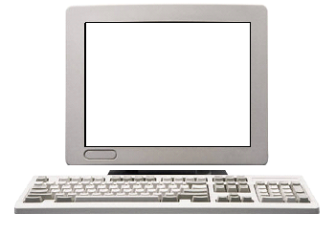
Camera
IEEE 1394a cable
PC with
IEEE 1394a card
Miabot
2.20 m
1.50 m
Bluetooth
LAN
Figure 1. The System Architecture of Indoor Localization System with Miabot

2.1. Camera Selection and Calibration
A Basler A311fc, colour camera of 658x492 pixels with IEEE 1394a interface, with 4.8mm Pentax lenses is chosen due to the limitation of the ceiling height at 2.50 m and the requirement of Miabot operating field of 1.50x2.20 m in our laboratory. With the camera placed 2.5 m above the floor, each square pixel is approximately equivalent to a 4x4 mm patch on the field.
Due to the wide angle lenses, the captured images are severely distorted. However the distortion effect can be corrected during camera calibration. The camera calibration program written in Matlab [9] is used to find the distortion coefficient. In addition, intrinsic and extrinsic parameters of the camera are also determined in this process. Table 1 shows the details of the intrinsic parameters and distortion coefficient in our camera setup.

Table. 1 Intrinsic Camera Parameters
Camera Intrinsic Parameters | Values (pixel unit)
Focal Length(fc)  fc = [f_{x ,} f_{y}] | f_{x} =494.78844  f_{y} = 499.67218
Principal Point (c)  c = [c_{x}, c_{y}] | c_{x} = 340.15176  c_{y} = 242.58152
Radial Distortion Equation  ( kc₁.r² + kc₂.r⁴ + kc₅.r⁶ ) | kc₁ = -0.24252  kc₂ = 0.08804  kc₅ = 0.00004

Note that r is a distance of a distorted position to an image centre in a pixel unit. kc₁, kc₂ and kc₅ are radial distortion coefficients. kc₃ and kc₄ are tangential distortion coefficients set to be zero as their values are considerably small.

2.2. Miabot
The Miabots are developed by Merlin Robotics [10]. Due to the physical size of Miabot, the colour marker of size 7.5x7.5 cm is placed on the top of each robot. The identification of each robot can be determined by a unique colour marker placed on each robot.

VISION ALGORITHM
The section details the vision algorithm of the localization system. The vision algorithm provides the method that extracts information from the captured image. There are two interested features extracted from the algorithm: coloured blob detection and blob position estimation.

3.1 YUV Colour Space
In a vision system, several colour spaces can be used to represent colour in an image, for example Red Green Blue (RGB), YUV, Hue Saturation Intensity (HSI) etc. The selection of any particular colour space is the result from a selection of hardware and its application. Our vision system uses YUV colour space for colour representation due to two reasons. First, A311fc camera has an option to transmit image data in YUV. Thus the camera colour space transformation is not required. In addition, YUV takes the advantage of the separation of luminance channel (Y) from chrominance channels (UV).
In order to determine UV threshold values for each colour, a set of five colour markers (red, green, blue, yellow and purple) were placed in different positions on the field. We then captured the image and plotted it on UV plane. By doing this we can determine the maximum and minimum threshold values from the pixel distribution for each colour on UV plane. Figure 2 shows the pixel distribution from each colour marker on UV plane. The rectangular box represents the maximum and minimum threshold values on U and V channels.
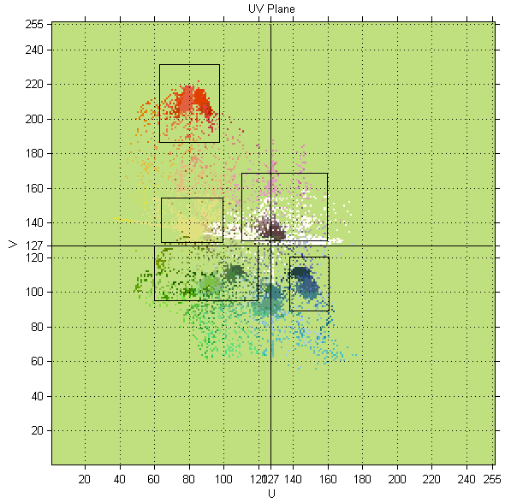
Figure 2. Values of U and V for Five Colour Markers

3.2 Vision Algorithm
The algorithm flowchart is shown in figure 3. The algorithm is started after the image is captured by the camera and then sent to the host PC in YUV colour space. The first step in image processing is colour segmentation. The thresholding method is used to segment each colour from the maximum/minimum values of U and V colour channel. Since the reflection of the fluorescent light from the sonar sensor, the robot body, floor etc, results in expected noise in the segmented image. The connected component labelling and component filtering, from the known object seize, are introduced in order to detect and sequentially filter out a noise. The two-pass technique [11], [12] in the labelling algorithm is selected because of its faster speed than other techniques, in most case without a specific hardware use.
In the next stage, we calculate the centroids of each detected coloured blob. Since the blob is represented by a set of 2D digitised pixels, its centroid can be calculated from the first-order moment of the blob area [13]. Due to distortion produced by the wide angle lenses used to capture the image, the next stage in our algorithm is to correct this effect. Centroid position of the detected blob is undistorted using distortion parameters and radial distortion model described in table 1. The final process in our algorithm is to transform the object coordinate from image to world frame coordinate. The calculation uses camera extrinsic parameters, determined during the camera calibration stage, and the coordination transformation defined in [14].
Image Acquisition
Blob Centroid Calculation
Calculation
YUV Colour Segmentation
Segmentation
Coordinate Undistortion
Connected Component Labelling
Component Filtering
Coordinate Transformation

Figure 3. Diagram of the Vision Algorithm

eXPERIMENTAL RESULT
Two experiments were conducted in order to determine the performance of the vision algorithm in the previous section. The first experiment uses a static measurement. The experiment involves placing robot manually on known positions. The second experiment is a dynamic measurement. The vision system measures the robot positions while robot is navigating on the floor.
4.1 Static Measurement
In order to determine the accuracy and precision of the vision system, the ground truth positions of the floor are carefully marked and rechecked by hand using an engineering ruler and square protractor. We then place a robot with marker on different 35 positions on the floor. At each position, 126 images are captured in order to determine accuracy and precision of our vision system. Figure 4 shows 35 positions where the robot was placed. The first position is at upper right corner and the last position is at the lower left corner. The arrow represents the direction of next position where the robot will be placed. The projected position of the camera, mounted on ceiling, is at the centre of the diagram, shown as the grey marker.
After taking 126 images, the robot positions are calculated using our vision algorithm. Consequently the absolute mean and standard deviation of position error are computed as follow.
$$μ_{x}=\frac{1}{N}\sum_{i=1}^{N}{\left|x_{i}−{\hat{x}}_{i}\right|}$$
$$μ_{y}=\frac{1}{N}\sum_{i=1}^{N}{\left|y_{i}−{\hat{y}}_{i}\right|}$$
Where $μ_{x}$and $μ_{y}$are absolute mean error in x and y coordinate respectively. $\left[x_{i},y_{i}\right]$ is the robot true position. $\left[{\hat{x}}_{i},{\hat{y}}_{i}\right]$ is the robot estimated position from our vision algorithm. $N$is number of the images taken at each position.
Figure 5 shows obtained results from the experiment. An accuracy of our system is described by the mean value of position errors. The result shows that our vision algorithm gives the maximum error of 27.72 mm and the minimum error of 0.22 mm. The overall means are 8.35 mm and 9.25 mm in x and y coordinates respectively. The result shows that our vision system is highly accurate than our previous IR localization system. The values of the maximum and mean error are very small, 15 – 43 times, comparing to the maximum error of 40 cm reported in the IR system [15]. Precision of the position measurement is described by standard deviation. It can be seen that the standard deviation is relatively small. Most of the values are less than 1.5 mm. The average standard deviations are 0.68 mm and 0.40 mm in x and y coordinates respectively. The result shows that the precision of the vision system is higher than the sonar localiser currently used in our laboratory. The result at the range of 8.46 mm from the sonar localizer reported in [16], is 1.9 times larger than most values we receive in our measurement.

40 cm
40 cm
40 cm
40 cm
30 cm
30 cm
1st
35th
30 cm
30 cm
30 cm
30 cm
Figure 4. Diagram in Static Measurement Experiment

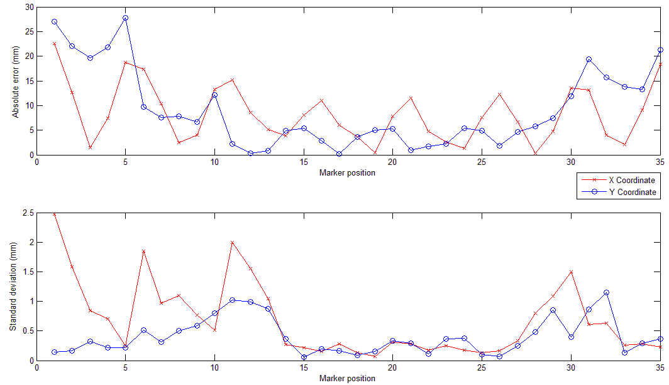
Figure 5. Absolute Error (upper) and Standard Deviation Error (Lower) of the Measured Robot position

The upper graph in figure 5 also shows that the position error is a function of a distance to an image centre. The further robot is placed away from the image centre, the higher position error increases. This results from the effect of the distortion in an image, from wide-angle lenses. The radial distortion equation in table 1 shows that the degree of an image distortion increases by the distance of the robot position to the image centre. The standard deviation graph shows the effect of the inhomogeneous brightness of the light in a robot field. Since the fluorescent lights are placed at the bottom, slightly to the left, of the robot filed, this makes the upper part of the field darker than the bottom part. This results in an increasing of noise in pixel because the values of U and V in YUV colour space are not laid within the UV threshold range.

4.2 Dynamic measurement
In this experiment, the robot is controlled to navigate using joystick controller while camera is taking images and calculate robot positions using our vision algorithm. In order to determine the true positions of robot trajectory, pencil are mounted underneath of robot. By doing this the true trajectory can be determined.
Figure 6 shows result from the experiment. The dotted trajectory represents the robot positions calculated by our vision algorithm. We also selected 7 positions from the true trajectory and then plotted them against the trajectory calculated by vision system. Note that the true positions are represented by X marker. The result shows that our vision algorithm successfully calculates the robot position while the robot navigates on the floor. At position 2, the estimate position is much closed to the true position. However when robot moves further away from the centre, we can observe that the estimation accuracy decreases. The change of the position accuracy in the dynamic measurement relates to the result from static measurement. Therefore, we can summarise that the vision algorithm is able to estimate the robot position while the robot moves.
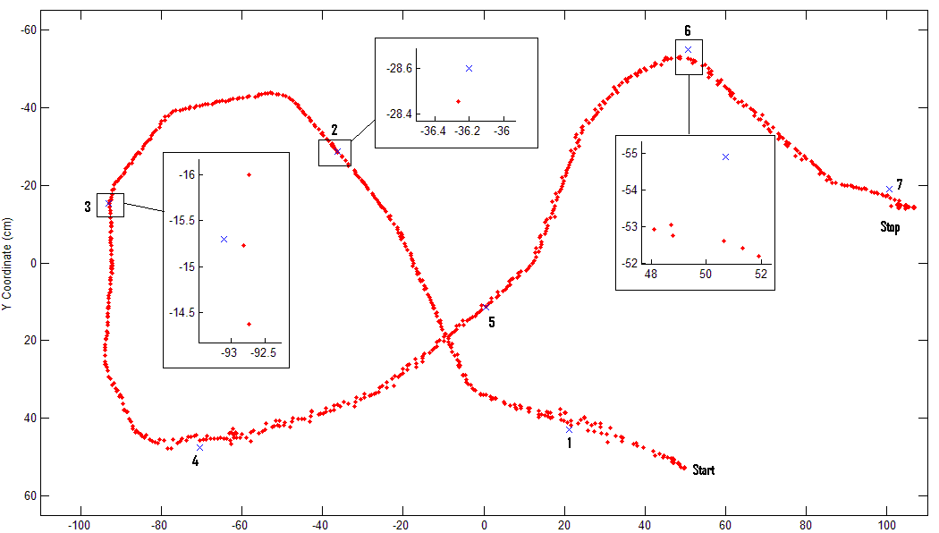
Figure 6. Trajectory of the Robot

In addition, we also investigate the execution time used by our vision system. With a setup of camera frame rate at 30 fps, our vision algorithm must finish all calculation within a time frame of 33.3 ms. An average usage time of 14.47 ms is achieved on a 1.6 GHz Turion processor with 1 Gbyte of RAM memory. Therefore, our vision algorithm is able to operate and locate the robot position in real time. Moreover, since the average usage time is very small, this allows us to increase a camera frame rate. A maximum camera frame rate of 50 fps, at a full resolution, can be set following this usage time.

conclusion
We have implemented and described the indoor localization system using camera vision. The accuracy and precision of the system are verified through the static and dynamic experiments. The result shows that our algorithm can locate the robot position with a very high precision, within 2 mm in most case. For accuracy, an estimated position is very accurate at the centre of the field. However we observe that the further robot moves away from the image centre, the lower accuracy in position estimation is achieved. This results from the distortion in an image from wide-angle lenses. At the distance of 125.3 cm from the centre, the maximum estimation error of 27.7 mm is observed. In addition we also show that our system is able to track the robot position in the real time manner. In addition, while we set the camera frame rate of 30 fps in the experiment, we show that we can increase the camera frame rate to 50 fps due to a small process time used in our vision algorithm. Finally we summarise that by using our high speed vision algorithm, the robot can be controlled to travel at high speed.

Future Development
The ultimate objective of our new indoor localization system for a team of robots is to integrate information from the vision system and the robot odometry. In order to optimally track the trajectory of the robots, the data fusion technique, Kalman Filter, will be introduced into the next stage. Then the global vision system will be used to provide the relative position measurement among the robot team. By doing this we are able to assume that each robot is equipped with the sensor that enable robot to sense and detect other robots in the team. We are interested in finding an algorithm for a stochastic robot selection to minimise the position estimation covariance. The term ‘stochastic’ here means that no constant or arbitrary topology of relative measurements between robots is defined. In addition, the stochastic selection also relaxes the constraint that the team of mobiles robots must maintain the predefined formation and move forward in the same direction and velocity. Therefore each robot is allowed to move freely to continue its task.
Finally, since it is very importance to have accurate levels of robot and vision noise information so that the filter measurements are incorporate to the right extent, the stepper motor system will be implemented. Also the new design of robot marker will allow the determination of robot position and direction.

references
- S. Fleck, F. Busch, P. Biber and W. Straßer, “Graph Cut based Panoramic 3D Modelling and Ground Truth Comparison with a Mobile Platform”, Proc. of the 3rd Canadian Conference on Computer and Robot Vision (CRV 2006), pp.19-19, 2006.
- P. Bahl and V.N. Padmanabhan, “Radar: An in-building user location and tracking system”, Proc. of the IEEE Infocom., Tel Aviv, Israel, pp. 775–784, pp. 775-784, 2000.
- L.E. Navarro-Serment, C.J.J. Paredis, P.K. Khosla, “A Beacon System for the Localization of Distributed Robotic Teams”, Proc. of the International Conference on Field and Service Robotics, Pittsburgh, PA, August 29-31, pp. 232-237, 1999.
- http://www.robocup.org/02.html
- M Borg, D J Thirde, J M Ferryman, K D Baker, J Aguilera, M Kampel , "Evaluation of Object Tracking for Aircraft Activity Surveillance", The Second Joint IEEE International Workshop on Visual Surveillance and Performance Evaluation of Tracking and Surveillance (VS-PETS 2005) in Beijing, China, pp. 145-152, 15-16th October 2005.
- W. Burgard, A.B. Cremers, D. Fox, D. Hähnel, G. Lakemeyer, D. Schulz, W. Steiner, and S. Thrun, "The Interactive Museum Tour-Guide Robot," Proc. of the Fifteenth National Conference on Artificial Intelligence (AAAI-98), pp. 11-18, 1998.
- I.D. Kelly, “The Development of Shared Experience Learning in a Group of Mobile Robots”, PhD Thesis, The University of Reading, 1997.
- I.C.B. Goodhew, B.D. Hutt and K. Warwick, “Control and Experiment of a Personal Robot Tracking System”, The Internal Journal of Modelling, Identification and Control, Vol. 1, No. 1, pp. 4-12, 2006.
- Jean-Yves Bouguet, “Camera Calibration Toolbox for Matlab”, http://www.vision.caltech.edu/bouguetj
- http://www.merlinrobotics.co.uk
- Kesheng Wu, Ekow Otoo and Kenji Suzuki, “ Two Strategies to Speed up Connected Component Labeling Algorithms”, Pattern Analysis & Applications, Springer London, pp. 1433-7541, March 04, 2008.
- T. Gotoh, Y. Ohta, M. Yoshida, and Y. Shirai, “Componentlabeling algorithm for video rate processing,” Proc. of SPIE 1987, ser. Advances in Image Processing, vol. 804, pp. 217–224, 1987.
- R. Jain, R. Kasturi and B. G. Schunck, “Machine Vision”, McGraw-Hill Inc., 1995.
- R. Y. Tsai, “ A Versatile Camera Calibration Technique for High-Accuracy 3D Machine Vision Metrology Using Off-The-Shelf TV Cameras and Lenses”, IEEE Journal of Robotics and Automation, Vol. 3, pp. 323-344, 1987.
- I. D. Kelly, A. Martinoli, “A Scalable, On-Board Localisation and Communication System for Indoor Multi-Robot Experiments”, Special Issue on Sensor Simulation and Smart Sensors, Sensor Review, Vol. 24, No. 2, pp. 167-180, 2004.
- C. Forster, “Small Autonomous Co-operative Wireless Mobile Robots for Building Environmental Representations, Project Report, The University of Reading, 2006.

