Supplementary Information

Self-assembly of Telechelic Tyrosine End-Capped PEO Star polymers in Aqueous Solution
Charlotte J C Edwards-Gayle, Francesca Greco and Ian W Hamley*
School of Chemistry, Food Biosciences and Pharmacy, University of Reading, Whiteknights, Reading RG6 6AD, U.K.
Robert P Rambo
Diamond Light Source, Harwell Science and Innovation Campus, Didcot, Oxfordshire OX11 0DE, U.K.
Mehedi Reza and Janne Ruokolainen
Department of Applied Physics, Aalto School of Science, P.O. Box 15100 FI-00076 Aalto, Finland.
Dimitrios Skoulas and Hermis Iatrou
Department of Chemistry, University of Athens, Panepistimiopolis Zografou, 157 71, Athens, Greece

* Author for correspondence

Figure S1. ¹H NMR spectrum of the 4-arm star [poly(L-tyrosine₄₋₅)-b-(PEO 2.5k)]₄ in DMSO-d₆.

Figure S2. ¹H NMR spectrum of the 4-arm star [poly(L-tyrosine₃₋₄)-b-(PEO 5k)]₄ in DMSO-d₆.

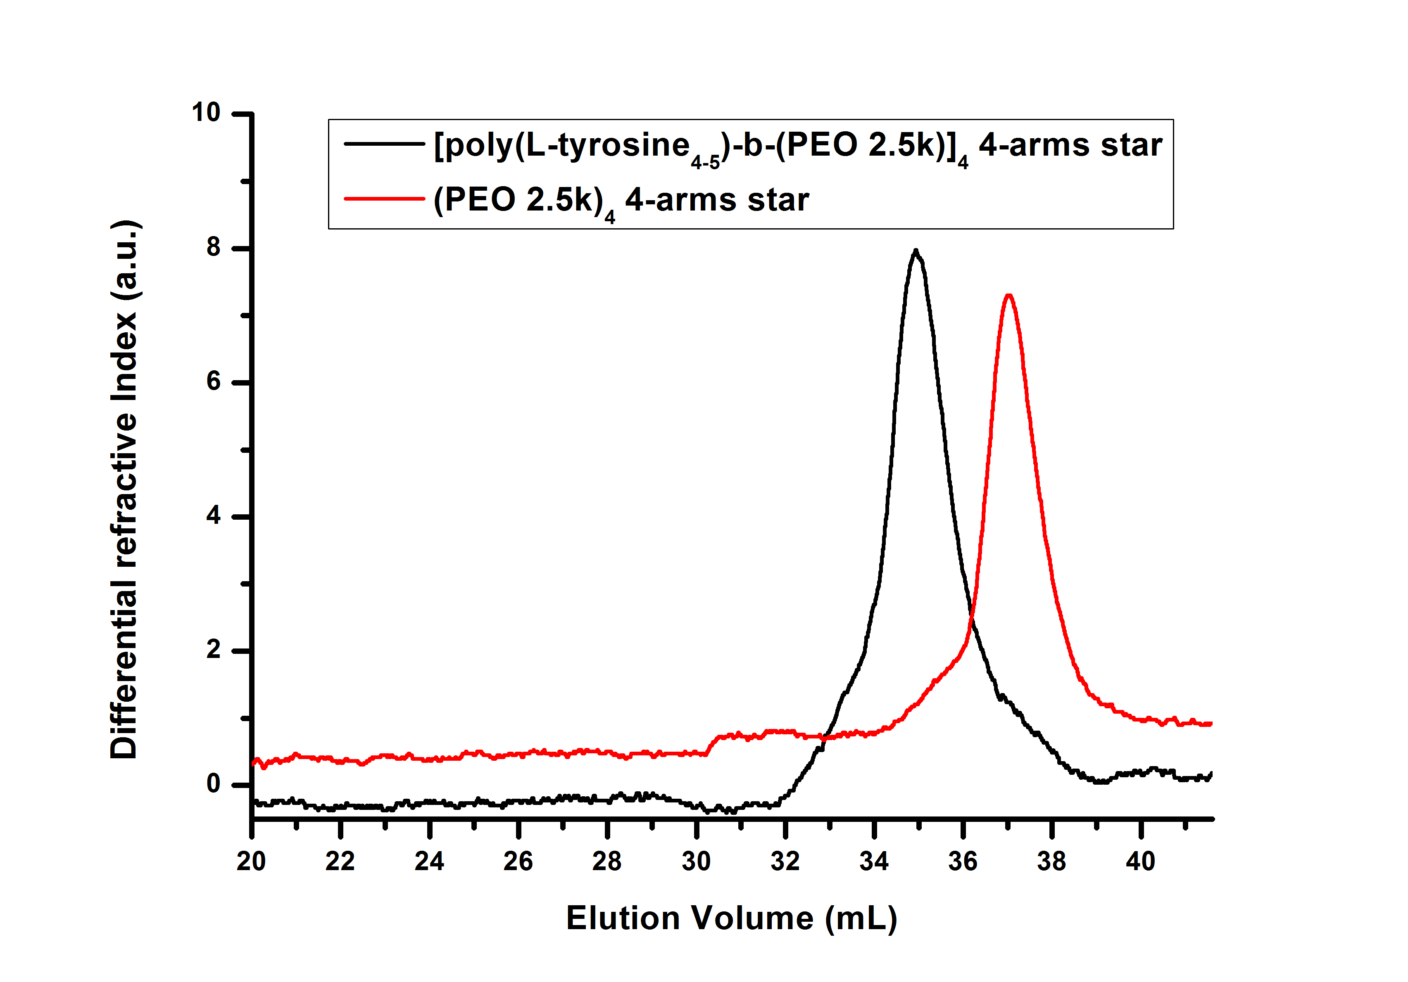
Figure S3. Size exclusion chromatographs of the 4-arm star [poly(L-tyrosine₄₋₅)-b-(PEO 2.5k)]₄ and precursor. A 0.1 N LiBr DMF solution was used as an eluent at a rate of 1 mL/min (SEC-TALLS).

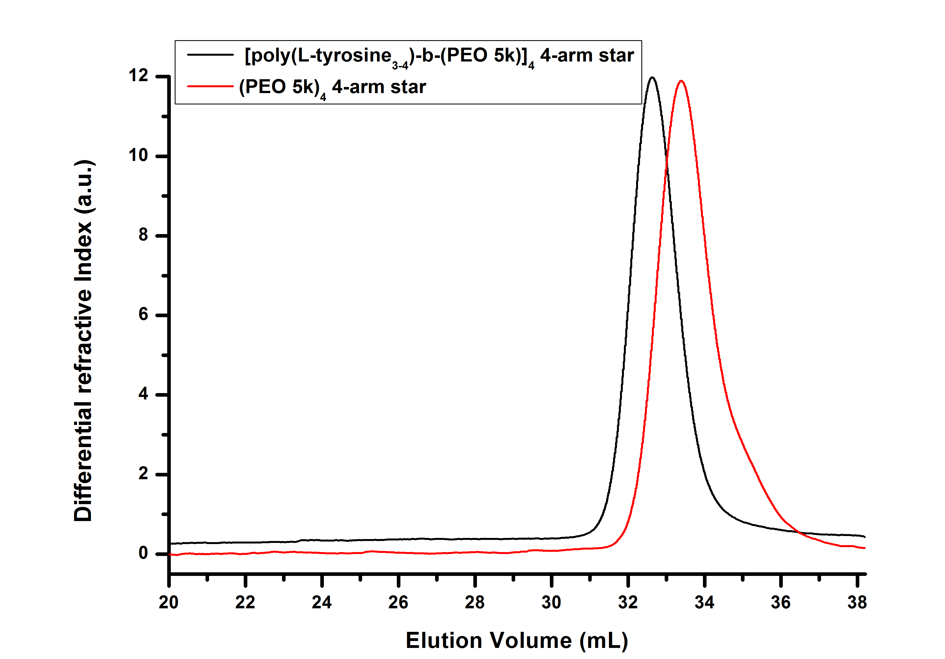
Figure S4. Size exclusion chromatographs of the 4-arm star [poly(L-tyrosine₃₋₄)-b-(PEO 5k)]₄ and precursor. A 0.1 N LiBr DMF solution was used as an eluent at a rate of 1 mL/min (SEC-TALLS).

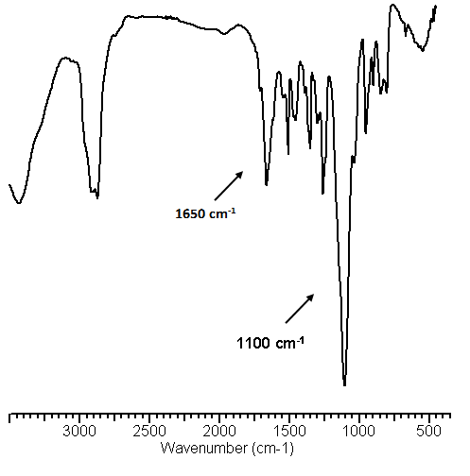
Figure S5. FTIR spectrum of [poly(L-tyrosine₄₋₅)-b-(PEO 2.5k). FTIR shows the development of the characteristic peaks of the peptide bonds at 1650 cm⁻¹ and the ether bonds at 1100 cm⁻¹ of PEO.

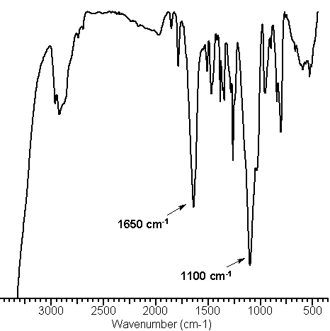

Figure S6. FTIR spectrum of the 4-arm star [poly(L-tyrosine₄)-b-(PEO 5K)]₄. FTIR shows the development of the characteristic peaks of the peptide bonds at 1650 cm⁻¹ and the ether bonds at 1100 cm⁻¹ of PEO.
Figure S7. CD spectra showing the reversibility of pH-induced conformational transitions. The reversibility of the CD spectra shows that the peptide does not decompose at high pH but rather unfolds and refolds.

Figure S8. X-ray fibre diffraction data obtained from dried stalks made from 3 wt% solutions of [poly(L-tyrosine₄₋₅)-b-(PEO 2.5K)]₄ and precursor molecule (PEO 2.5K)₄. Selected d-spacings in Å are indicated

Figure S9. X-ray fibre diffraction data obtained from dried stalks made from 3 wt% solutions of [poly(L-tyrosine₃₋₄)-b-(PEO 5k)]₄ and precursor molecule (PEO 5k)_{4.} Selected d-spacings in Å are indicated.

Figure S10. Less common self-assembled structures observed by cryo-TEM for the conjugates. a) [poly(L-tyrosine₄₋₅)-b-(PEO 2.5k)]₄ pH 12 shows occasional spherical structures. b) (PEO 2.5k)₄ shows occasional spherical clusters. c) [poly(L-tyrosine₃₋₄)-b-(PEO 5k)]₄ pH 7 shows occasional short straight fibres and longer fibres. d) [poly(L-tyrosine₄)-b-(PEO 5k)]₄ shows occasional very long fibers, e) (PE0 5k)₄ shows occasional large clusters.

Figure S11. Kratky plots of the SAXS data for precursor molecules, consistent with branched conformation.

Figure S12. Cytotoxicity profile of tyrosine showing that it does not have a significant effect on cell viability. Concentrations were chosen based on the tyrosine content in each of the precursor molecules. The highest concentration of tyrosine, present in 5 mg/ml of the [poly(L-tyrosine₄₋₅)-b-(PEO 2.5k)]₄ could not be tested with the MTT assay due to tyrosine solubility, the limit of which is 0.45 mg/ml in water.

