A FRAMEWORK OF procedural considerations for implementing immersive VIRTUAL environments IN DESIGN REVIEWS
Silvia Mastrolembo Ventura^{1,2}, Fadi Castronovo³, Dragana Nikolic⁴ and Angelo L.C. Ciribini²
¹Politecnico di Milano, Milano, Italy
²University of Brescia, Brescia, Italy
³ California State University East Bay, Hayward, United States of America
⁴University of Reading, Reading, United Kingdom

Abstract
The implementation of immersive virtual reality in the construction sector is experiencing a period of renewed interest since the earlier research efforts of the 2000s. VR-related applications are increasing in number and scopes, with a focus on communication and analysis of design intents. On the other hand, some obstacles still exist from both technological and procedural perspectives. Focusing on the latter, the paper proposes a framework of procedural considerations for implementing virtual reality systems in design reviews, especially when clients and end-users are involved. The framework is the result of a qualitative research based on seven semi-structured group interviews with a representative panel of design stakeholders (i.e., twenty-four participants, including clients, designers, end-users and an accessibility expert), who were asked to evaluate immersive VR for the usability-focused analysis of a new school building.

Introduction
Research and applications related to Virtual Reality (VR) in the Architecture, Engineering, Construction and Facility Management (AEC/FM) industry are steadily increasing in number and scopes. This growing interest in VR systems, which are currently considered as one of the next trends of digital innovation (Mansouri & Akhavian 2018), is closely linked to the ever-increasing adoption of Building Information Modelling (BIM) processes, procedures and technologies that characterises the on-going digital transition of the industry.
Practices of developing virtual prototypes in product design as well as perspectives from both academia and industry in the construction domain show how virtual reality systems, also seen as interactive workspaces (Lather et al., 2018), support collaboration through improved communication and access to information for all involved stakeholders, regardless of their technical background. Previous research indicates the ability of VR systems to reduce the communication gap between the demand (e.g., clients, owners, end-users) and supply (e.g., design team) sides of the building process, thus providing the conditions for better collaboration among stakeholders (Paes et al., 2017).

VR systems and virtual facility prototypes
Virtual prototypes of design proposals are in product design known as the anticipation of a product that does not exist in reality yet (Bordegoni & Rizzi, 2011). Virtual prototypes of new buildings and virtual representations of existing buildings can also be effectively explored, tested and evaluated (Tutt & Harty, 2013) not only by the design team and the supply network, but also by engaging stakeholders such as clients and end-users, who may lack technical expertise, to more effectively participate in the decision-making processes compared with using traditional representations (e.g., 2D drawings, renderings, video-renderings) (Van den Berg et al., 2018; Castronovo et al., 2013; Bullinger et al.; 2010).
Often, the use of virtual prototypes implies the use of virtual reality as the visualization and interaction platform that can further enhance their exploration and testing. Through immersion and sense of presence, immersive (or semi-immersive) virtual reality allow stakeholders to experience a design proposal at full-scale in an intuitive and engaging manner. Semi-immersive VR is an experience where a portion of the user’s field of view is covered by the system, whereas in a fully immersive VR experience the user’s entire field of view is covered by the system (Shiratuddin et al. 2004; Castronovo et al. 2013) thus increasing the sense of presence within the virtual prototype.

Immersive Virtual Reality in usability-focused design reviews
Previous studies discuss a range of virtual prototypes and virtual reality uses in different project phases and purposes of the building process. In particular, the role of virtual prototypes in VR is recognised to support the generation of ideas more than physical prototypes (Tiainen et al., 2014). Communication and review of design proposals are the main purposes for implementing virtual reality in BIM-based design processes (Lather et al., 2018). Virtual reality has also been applied in previous research as an occupancy evaluation tool to support clients, end-users and facility managers in collaboratively evaluating the functionality and usability of building spaces, with the aim to reduce the gap between design and operations (Mastrolembo Ventura et al., 2018; Tseng et al., 2017; Liu, 2017). For example, Liu et al. (2014) showed how virtual reality models allow reviewers to deeper understand the implications of design decisions. Van den Berg et al. (2017) reviewed the literature to explore how design reviews can be supported with immersive virtual environments to communicate design intent as well as to ask for design feedback, allowing designers and clients to navigate through and comment on a design in progress. Exploration from a user perspective, participation in solution-finding and feedback on a design proposal are the theoretical patterns they identified.

Research gap and scope of the paper
While research in the application of virtual reality systems in the AEC/FM industry is growing, some obstacles to its effective implementation still exist from both a technological and, above all, procedural perspective. Regarding the former, for example, the BIM-to-VR workflow is not as smooth as it should be for an extensive VR implementation (Hilfert & Konig, 2016). Moreover, a few researchers have started to quantitatively compare how immersive and non-immersive VR affect user performance during design review (Paes et al., 2017). Furthermore, the evaluation of how different input systems, enablers for sensory feedback, may affect sense of presence and user performance is lacking. Finally, the possibility for using VR in asynchronous and remote design review still have to be further investigated (Van den Berg et al., 2017). Procedural challenges, instead, are primarily illustrated by instances where the lack of a clear design review agenda, unguided navigation through the model, or the level of detail or realism can greatly affect the quality of the feedback and overall effectiveness of the design meeting (Whyte & Nikolic, 2018; Whyte, 2002; Liu et al. 2014). Moreover, motion sickness and user experience with VR systems also affect the result of the design review (Khashe et al., 2018).
The need for addressing this type of issues in a more systematic way as a guide for the design teams when planning to use VR with other stakeholders is within the scope of this study, which proposes a framework of procedural considerations for implementing virtual reality in collaborative design review meetings. In order to address these obstacles, the authors, in previous research, proposed the development of a process map as the first step towards developing procedural guidelines for the effective use of VR in design review meetings (Mastrolembo Ventura & Castronovo, 2018).

Methodology

Data collection
A qualitative research strategy has been applied, which is based on seven semi-structured group interviews with a representative panel of stakeholders (i.e., twenty-four participants including clients, designers, end-users and an accessibility expert) (Table 1). The aim of the interviews was to investigate process-related aspects, including contractual issues for adopting virtual reality in design review meetings from the perspective of potential design stakeholders. The interviewees (designers and clients) were selected based on their previous experience with BIM implementation and involvement with design and procurement of educational projects respectively. Moreover, an accessibility expert, who is both a designer and a wheelchair user, was involved, as well as a representative panel of end-users (i.e., school directors, students, teachers, parents) of a similar education building. Their experience with VR systems was not considered.

Table 1: Organisation of the interviews
Session | Stakeholders involved |  | Participants (n.)
1. | BIM manager (architecture) |  | 1
2. | Designer - Accessibility expert |  | 1
3. | BIM manager (architecture) |  | 2
4. | Public client |  | 3
5. | BIM manager (architecture, structure, MEP) |  | 3
6. | End-users (director, teachers, students, parents) |  | 11
7. | Public client |  | 3
Total number of participants |  |  | 24
Before starting the interviews, participants were first briefed on the objective of the research and then introduced to the VR environment, learning how to use it to move and interact within the virtual environment (Figure 1). In this semi-immersive multi-user single-wall VR environment (Figures 2 and 3), they were then asked to review the design proposal of a new public educational building. In particular, they were asked to review operational requirements related to the functionality and effectiveness of internal spaces based on their use and destination (Table 2).
The VR environment featured a stereoscopic projector and a single portable rear-projected wall with a user-tracking system, while a 3D mouse, a flystick and a keyboard were used as VR controllers. The Virtalis Visionary Render visualization package was used to import the Industry Foundation Classes (IFC) version of the building information model into the immersive virtual environment and to prepare the VR representation. Though the use of this specific type of VR system was determined by its availability, the focus was not on the system but on the user experience while using it (Paes et al., 2017).
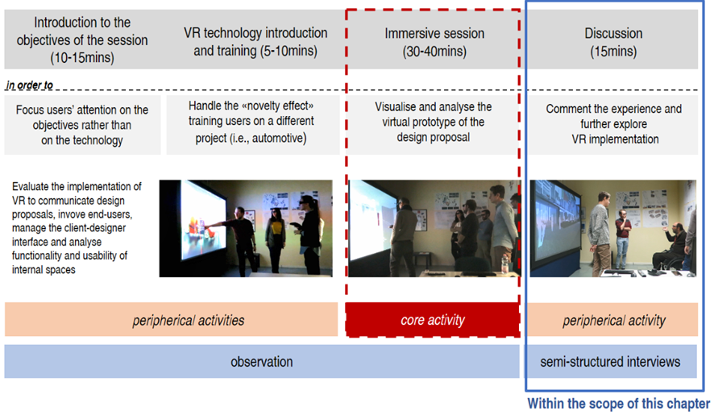

Figure 1: Agenda of the meetings with the interviewees

Table 2: Design requirements taken into account
Operational requirements of functionality and effectiveness for internal spaces of innovative schools
1. | Functionality of internal spaces in relation to their use and destination
2. | Effectiveness of spaces to ensure learning paths and innovative learning methods
3. | Accessibility and safety of circulation paths
4. | Interchangeability of space functions: classroom/laboratory
5. | Flexible aggregation of contiguous spaces to form larger one and vice versa
6. | Upgrading of circulation spaces for teaching or aggregative use

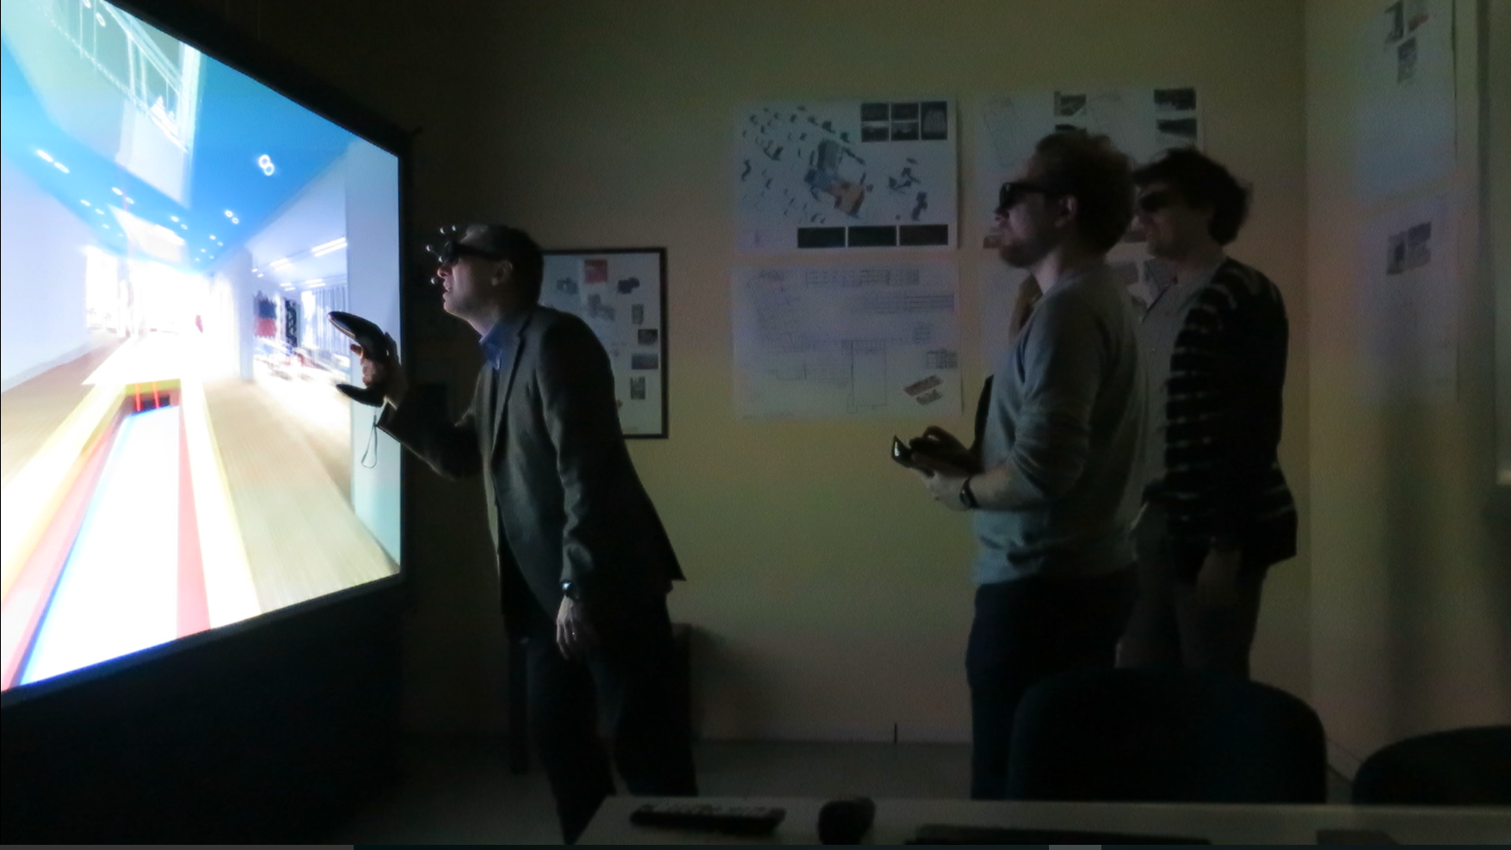
Figure 2: Interaction with the virtual facility prototype
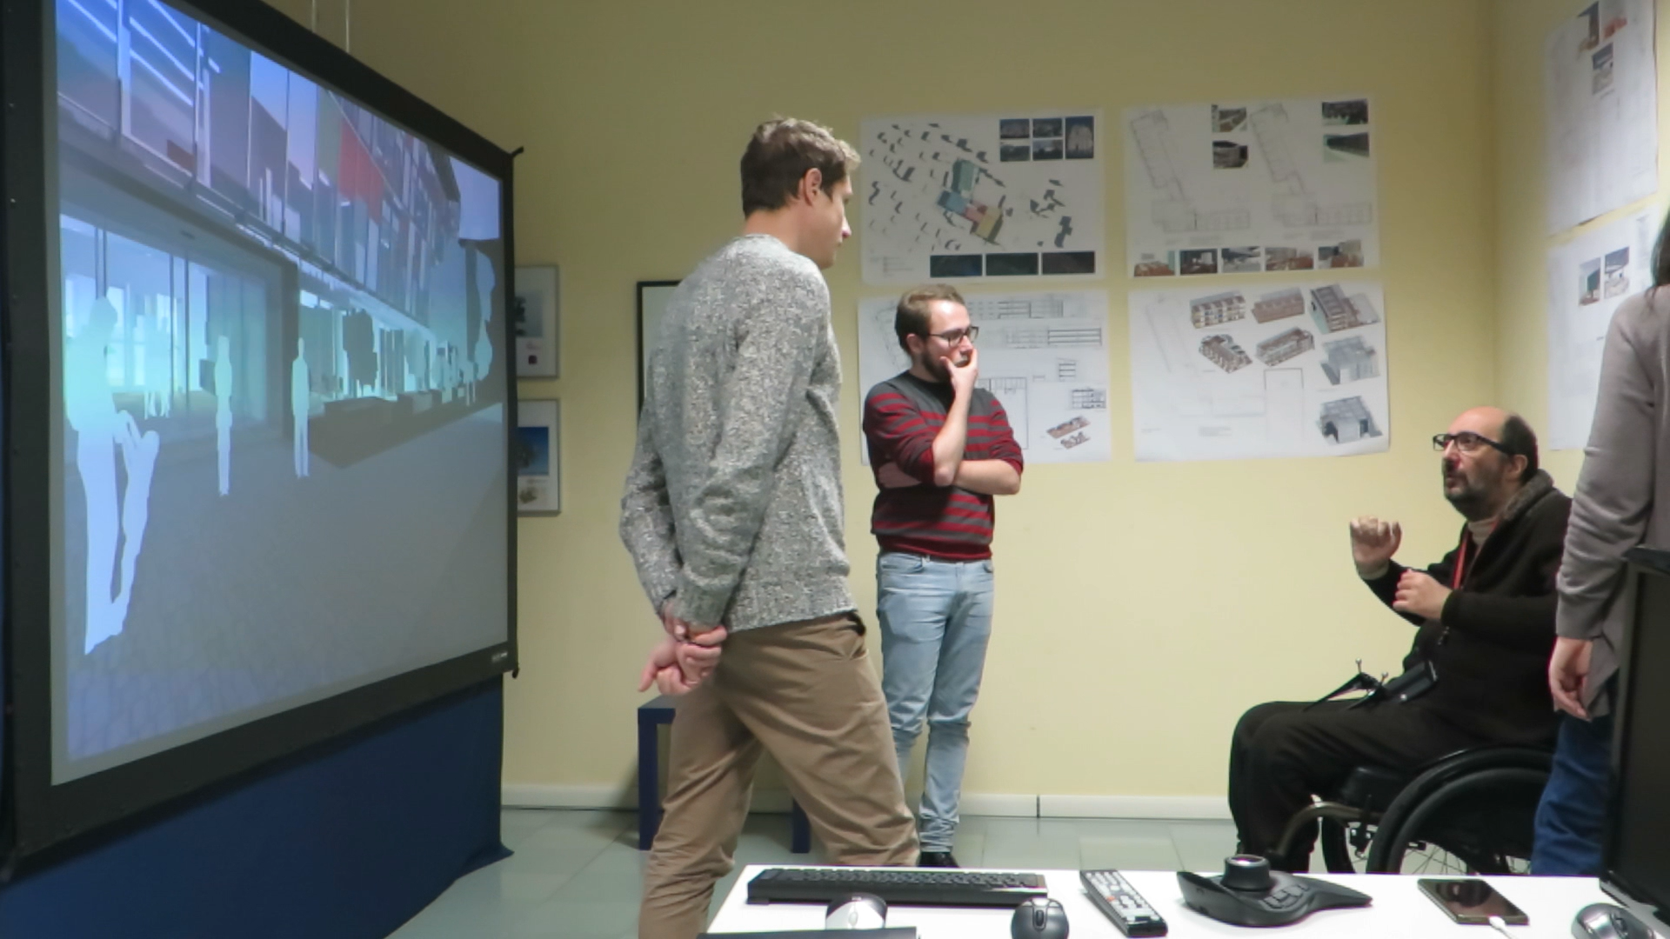
Figure 3: Review of the design proposal
The semi-structured interviews consisted of open-ended questions organised into five topics (Table 4). The method of multiple investigators (Kathleen, 1989) was adopted for collecting data, with team members having unique roles during data collection: one of the researchers, acting both as a facilitator during the design review and interviewer had a more personal interaction with the interviewees. Other three members of the research team were responsible for supporting the VR experience and, then, for audio and video recording the interview. Because of time constraints, two interviews (i.e. S5 and S6) were not possible to conduct separately from the meeting, so the interview questions were instead used to facilitate the discussion during the navigation within the virtual prototype. Data were collected and stored to be subsequently analysed.

Data analysis
An inductive grounded theory approach was applied to the analysis of qualitative data, which have been first coded, identifying key points of the data to be gathered, and then grouped into concepts and categories of concepts that have been finally used for generating the proposed contribution.
In order to code the interviews, the transcripts were imported in NVivo 12 software (Aksenova et al., 2018) as text files (i.e., *.docx format), organised in cases, which represent the units of observation of the analysis, and then classified by the profile of relevant stakeholders (i.e., designers, accessibility expert, clients, end-users) (Table 3).

Table 3: Interview transcripts organised in cases and classified by stakeholders
Case classification | Files (n.)* | Participants (n.) | Hours of interview
Designers | 3 | 6 | 1h40min
Public clients | 2 | 6 | 1h
End-users | 1 | 11 | 40min
Accessibility expert | 1 | 1 | 30min
Total: | 7 | 24 | 3h50min
*One file corresponds to one group interview
During the interview analysis, sentences or group of sentences were assigned to primary codes. Primary codes, in their first version, reflected the interview plan and the related topics, including the primary set of categories and focus areas (Table 4). In a second round of coding, some sentences or groups of sentences have been re-assigned to new codes, which have been grouped as secondary level codes and, in some cases, as third level codes. Decision of code assignment was carried out by the authors based on “personal judgement and interpretation of what the sentences conveyed” (Suwal & Singh, 2017). The emerging concepts from the interview analysis were grouped under categories of concepts. Through the coding process of the interviews, further categories emerged in relation to stakeholder engagement. Moreover, twenty-one secondary level and twelve third-level codes emerged as well (Table 5).
The assigned codes were rechecked iteratively in order to validate that the various sentences and groups of sentences were assigned to the right codes. The iterative validation of codes was executed multiple times in order to ensure that the assigned codes were accurately mapped to interpret the answers (Suwal & Singh, 2017).

Table 4: First version of the coding schema based on the interview plan
Primary codes | Focus
Contractual aspects | to evaluate if the implementation of VR systems might be correlated to contractual constraints
Level of geometrical detail | to understand how to manage the VR representation at different design phases and purposes of VR adoption
Design phases for VR implementation | to define the most appropriate stages when VR might be adopted to support collaboration and decision-making
Communication with clients end-users in VR | to consider the value of VR in supporting communication among the demand- and supply-sides of the design process
Usability evaluation of internal spaces using VR | to evaluate if VR improves the understanding of usability issues in a design proposal compared to traditional representations

Code hierarchy based on number of coded references
Once the coding was concluded, a hierarchy chart of nodes based on number of coding references, as specified in Table 5, was developed in order to support data interpretation, which has been developed adopting a narrative approach. A hierarchy chart of nodes indicates how often a particular code (i.e., category of contents) is observed in the analysed data. The chart in Figure 5 was exported from NVivo 12; a larger area indicates a higher number of coding references for a certain node of the coding tree and thus categories of contents that have been more discussed than other by the interviewees.
Contractual aspects, level of geometrical detail, communication with clients and end-users and stakeholder engagement are the categories within the scope of this study.

Discussion and results

Contractual aspects for implementing VR
Clients and designers were those who discussed the contractual aspects of VR implementation the most, focusing on related procedural considerations (Table 6). In particular, according to the designers, the adoption of VR in the process should be managed as one of BIM uses (Kreider 2013). According to some of the participants, the implementation of VR should be based on the project objectives and information requirements as defined by the client in the Employer Information Requirements (EIR) (Quote_S1, S3, S5). For that reason, in their opinion, the implementation of VR should be considered as a rewarding factor during the tender evaluation in public procurements (Quote_S1, S3, S5). One of the designers stated to be ready to submit VR-compatible versions of a BIM model, considering it as:
“A further tool the client has to evaluate the design proposal in a more transparent way and to support the selection of the most valuable design proposal.” (Quote_S1)
The majority of the designers, however, is ready to propose the use of VR in their pre-contract BIM Execution Plan (BEP) and to invest in the adoption of the necessary technology only once their tender offer is selected, emphasising a more project-level approach rather than an organisational one to the implementation of virtual reality (Quote_S3, S5).
According to clients, the implementation of VR is not a priority in the digitisation of public authorities as required by the Italian BIM mandate, which requires a gradual and mandatory implementation of BIM from 2019 in public procurements (Quote_S7). However, in their opinion the support that VR provides to public clients in the analysis and communication of design proposals is evident and its implementation should be rewarded in the evaluation of tender offers and the subsequent selection of a design team (Quote_S4, S7).
According to public clients, the use of VR potentially supports (1) collaborative practices as participatory design, which, as they suggested, should be investigated in further research activities, (2) the multidisciplinary design coordination and (3) the review of a design intent, going behind normative texts and rather taking into account how the building will be effectively used (Quote_S4, S7). On the other hand:
“VR does not change the nature of public contracts. What has to be investigated is rather when to implement VR to involve end-users in order to effectively manage the design changes, for example the ones related to the functionality of the internal spaces, that this tool will inevitably stimulate the need for”. (Quote_S7)
Moreover, when it comes to end-user engagement, public clients also highlighted another issue where:
“The design review session should be guided (by the designers following pre-defined paths) because (virtual reality) is a system to visualize the design proposal that does not change the nature of contracts: the problem is not the tool, but when it is used and when a variation is requested”. (Quote_S7)

Level of detail considerations
The level of geometrical detail and the level of information embedded within a BIM object represents the degree of reliability to which a BIM use is implemented (Kreider, 2013). The participants were asked to express their opinion about the necessary geometrical detail to evaluate the functionality of the internal spaces of the design proposal and to suggest what procedural
Table 5: Final coding schema
Primary codes | 2nd level sub-codes | 3rd level sub-codes | Files | Ref.
1_Contractual aspects |  |  |  | 39
1_Contractual aspects | 1.1_Award procedure |  | 7 | 27
1_Contractual aspects | 1.1_Award procedure | 1.1.1_Transparency | 3 | 4
1_Contractual aspects | 1.2_Costs |  | 5 | 6
1_Contractual aspects | 1.3_EIR |  | 2 | 4
1_Contractual aspects | 1.4_Process management |  | 1 | 2
2_Level of geometrical detail |  |  |  | 106
2_Level of geometrical detail | 2.1_Materials |  | 4 | 10
2_Level of geometrical detail | 2.2_Lighting |  | 1 | 1
2_Level of geometrical detail | 2.3_Furniture |  | 7 | 26
2_Level of geometrical detail | 2.4_Stage of the project |  | 3 | 5
2_Level of geometrical detail | 2.5_Type of stakeholder |  | 7 | 20
2_Level of geometrical detail | 2.5_Type of stakeholder | 2.5.1_Expectations | 7 | 15
3_Design phases to implement immersive VR |  |  |  | 73
3_Design phases to implement immersive VR | 3.1_Brief |  | 2 | 2
3_Design phases to implement immersive VR | 3.2_Concept design |  | 7 | 21
3_Design phases to implement immersive VR | 3.3_Detail Design |  | 7 | 32
3_Design phases to implement immersive VR | 3.4_Technical design |  | 5 | 14
4_Communication with clients and end-users |  |  |  | 153
4_Communication with clients and end-users | 4.1_Design visualization |  | 7 | 107
4_Communication with clients and end-users | 4.1_Design visualization | 4.1.2._Rendering | 4 | 14
4_Communication with clients and end-users | 4.1_Design visualization | 4.1.3_BIM Model | 4 | 40
4_Communication with clients and end-users | 4.1_Design visualization | 4.1.4_2D drawings | 7 | 25
5_Design review using VR systems |  |  |  | 175
5_Design review using VR systems | 5.1_Usability-focused analysis |  | 7 | 98
5_Design review using VR systems | 5.1_Usability-focused analysis | 5.2.1_Functional layout | 5 | 27
5_Design review using VR systems | 5.1_Usability-focused analysis | 5.2.2_Flexibility | 5 | 16
5_Design review using VR systems | 5.1_Usability-focused analysis | 5.2.3_Design optioneering | 6 | 17
5_Design review using VR systems | 5.3_Code Checking |  | 6 | 21
5_Design review using VR systems | 5.3_Code Checking | 5.3.1_Accessibility | 3 | 14
5_Design review using VR systems | 5.3_Code Checking | 5.3.2_Egress analysis | 3 | 3
5_Design review using VR systems | 5.4_Clash detection |  | 3 | 4
5_Design review using VR systems | 5.5_4D modelling |  | 1 | 1
6_Stakeholder engagement |  |  |  | 141
6_Stakeholder engagement | 6.1_Clients |  | 6 | 33
6_Stakeholder engagement | 6.2_End-users |  | 7 | 37
6_Stakeholder engagement | 6.2_End-users | 6.2.1_Needs of end-users | 3 | 11
6_Stakeholder engagement | 6.3_Collaboration |  | 3 | 7
6_Stakeholder engagement |  | 6.3.1_Preparation of VR experience | 2 | 2

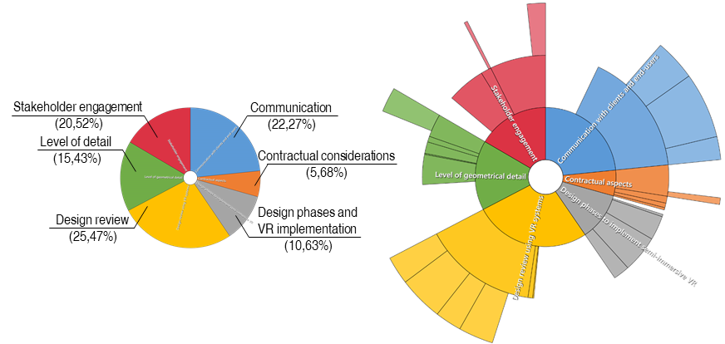
Figure 5: Hierarchy chart of primary codes (left) and sub-codes (right) based on the number of coding references as specified in Table 5.

considerations could be taken into account in relation to that specific aspect of VR implementation (Table 7). The presence of furniture, the use of textures and the lighting settings have been the aspects the participants considered the most (Figure 6, Figure 7).
Figure 6: The corridor of the primary school with furniture and flexible walls becomes an educational space
According to the designers, the level of geometrical detail for the representation of a design proposal within the virtual environment depends on (1) the purpose of the VR implementation, (2) the design phase when VR is implemented and (3) the stakeholders involved in the design review session (e.g., their level of technical expertise) (Quote_S1, S3, S5).
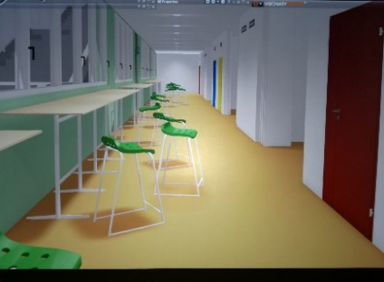
Figure 7: The corridor of the secondary school furnished for individual study
In relation to the purpose of VR implementation, the level of detail should be enough to allow stakeholders to evaluate the functionality of internal spaces. According to the accessibility expert, for example:
“If the accessibility of the internal spaces is considered and it is within the scope of the analysis, it means that elements that are strongly related to how a wheelchair user interacts with the space, such as, for example, the height of edges and handles of doors, as well as the height of sockets should be included in the virtual facility prototype”. (Quote_S2)
Moreover, the interaction with pieces of furniture is needed to evaluate the flexibility and accessibility of internal spaces and they have to be included within the virtual prototype even if they are just placeholders to simulate how the end-user interacts with them within the designed space. In fact:
“The problem of accessible spaces is that, when furnished, they can become inaccessible. With virtual reality, I perceive the space and its relationship with furnishing going behind normative requirements: it is necessary”. (Quote_S2)
On the other hand, other interviewees highlighted how the level of detail should also be considered from a contractual point of view because of the possibility that end-users may expect to see in the final building what they have experienced in the simulation (S3, S5). The presence of furniture is considered as an example: the building information model explored in VR contains pieces of furniture, which strongly characterise the design of the internal spaces (Figure 7, Figure 8). They are an essential part of the design of innovative schools and are needed to effectively evaluate the functionality and flexibility of learning environments. For example, one of the public clients said:
“The furniture defines the multifunctional spaces where teaching is done in an innovative way. I perceive the ennobling of the corridor as learning space much better than on 2D drawings. To date (to represent the same design aspect) they use renderings and text descriptions, while with immersive VR the communication of the design intent would be more effective.” (Quote_S7)
On the other hand, according to the different types of public procurements, it may be possible that the furniture is not actually included within the design phase but demanded at a later stage of the building process and to the responsibility of other stakeholders (Quote_S4, S7). For that reason, the understanding of what should be included in the VR representation based on the stakeholders involved and the objectives of the design review session is essential and should be well discussed during the preparation of the meeting and the related development of the VR scenario (Quote_S7).
Regarding the target audience for using VR, managing the (end-users’) expectations in the design review meeting has been the most discussed topic. For example, according to clients and designers, members of the design team understand that the proposed furniture might be just an example. On the other hand, end-users need more information in relation to how the building will be actually used in order to better understand the design and provide their feedback. When preparing a VR representation, the risk exists for too much realism, such as in textures and furniture that could create an expectation in end-users and clients. One of the architects involved in the VR sessions said:
“Users expect what they see, while designers know it may be just a placeholder. Not using textures would make the representation less misleading and avoid creating an expectation. The risk is that a strong characterisation of the space will become deceptive. The risk of creating false expectations already exists in renderings and in traditional representations.” (Quote_S3)
Public clients agree with the need to calibrate the level of detail based on the stakeholders involved in the VR-aided design reviews. One of them said:
“The detail becomes an obstacle and not a help in participatory planning and stakeholder engagement because it confuses and creates expectations. What really counts is the functional, distributive and organisational aspect of the spaces.” (Quote_S7)
Moreover, the need to declare the level of detail of the VR representation at the beginning of the VR-aided design review session emerged. One of the clients said:
It is necessary to declare at the beginning (of the immersive session) what is decided and what is only a suggestion and a symbol. As a school director, I would have difficulty understanding what is contractual and what is not in this representation and to provide my feedback. For that reason, I would not show this representation to an end-user unless the elements in that are decided. In design phases in which decisions have not yet been taken, it is preferable to use neutral textures. (Quote_S7)
The end-users involved in the research confirmed such statements, further highlighting the need to consider the use of characterising elements such as furniture and textures within the virtual environment in order to avoid disappointment.
The level of detail of the virtual facility prototype should also be compliant with what is required for each design phase in the public procurement code (Quote_S4, S7). In relation to the design phases, one of the designers suggested that:
During the concept design the graphical representation of the building information model within the virtual environment should include volumes and masses in order to allow stakeholders to evaluate overall dimensions of functional units and the interface between the building and the external context. During the detail design phase, instead, the level of detail should increase in order to allow users to evaluate internal spaces and circulation paths during the immersive sessions. (Quote_S1)
Table 7: Level of geometrical detail of the VR representation
Consideration | Description
Level of detail of the virtual prototype | Set the level of detail of the VR representation considering (1) the purpose why VR is used; (2) the design phase; (3) the stakeholders engaged in the meeting and their needs (avoid realism if not necessary)
Level of information need of the virtual prototype | Align the level of information need of the virtual prototype with what is required for the specific stage of the design process for taking decisions
VR preparation | Schedule a preliminary VR preparation phase, investing time in delivering an appropriate virtual prototype based on what previously specified
Management of expectations | Declare the level of detail during the meeting through visual cues to discern the decisions already made and those to be made about the design aspects (neutral for non-decided)

Communication with clients and end-users
Participants were asked what they believe to be the communicative potential of the VR system they tested before the interview (Figure 1) and how this could support, in their opinion, the effective communication of design intent to clients and end-users (Table 8). All the stakeholders expressed a positive opinion, highlighting the differences with traditional 2D drawings and renders; which were also available in the room to support design understanding. For example, one of the designers commented that the communication of the design proposal in a design review meeting typically starts with the floor plans followed by non-interactive renderings and videos (S1). In this process:
“VR systems are useful for an immediate perception of the spaces that only technical experts can otherwise understand based on traditional representations.” (Quote_S3)
At the same time the type of representation used will depend on the skill and background of the participant:
“As a designer I need to start from 2D drawings; it may be different for clients and for digital natives as the students. It would be interesting to evaluate it”. (Quote_S3)
On the other hand, the school director as one of the end-users argues:
“This [VR] type of representation allows us to better understand the design proposal and formulate an idea of the spaces stronger than looking at 2D drawings. We actually do not know how to read 2D drawings.” (Quote_S6)
Thus, even if using virtual reality, multiple modes of representation would be needed to support the communication of the design proposal, including more conventional representations (Quote_S1, S3, S4). This has been also previously confirmed through the need for multimodal and interactive spaces, rather than VR alone (Lather et al., 2018, Balakrishnan et al., 2006).
Table 7: Procedural considerations to support the communication of design intents using immersive virtual environments

Consideration | Description
VR as a medium in an interactive workspace | Provide stakeholders with multiple media to access design information based on their needs and technical expertise. An interactive workspace should be set
Risk for novelty effect and motion sickness | Manage the risk for a dispersive and unfocused session, considering that a novelty effect could influence stakeholders as well as motion sickness could reduce their performance because of discomfort and nausea

Stakeholder engagement
Whereas communication here means “to present information about a facility in a method in which it can be shared or exchanged” (Kreider, 2013); to engage users, means to allow them to “express their views in an environment that is conducive to obtaining an honest and accurate understanding of their needs” (BS 8536-1:2015). Interviewees also discussed how virtual environments could engage stakeholders in design review meetings, effectively involving clients and end-users. All the participants expressed a positive opinion, highlighting the differences between a VR-aided design review meeting and traditional processes. According to the accessibility expert, for example:
“Immersive reality has the potential to become an important tool for soft landings, as a communication bridge between the design and the occupancy of the building.” (Quote_S2)
Moreover, in another meeting, three designers with different backgrounds all agreed in saying that:
“The immersive virtual environment should be used in order to engage end-users in the design process so that they can express an opinion and provide feedback”. (Quote_S5)
The participants discussed the potential benefits VR systems could provide to collaboration, as well as to the demand-side (i.e., clients, end-users) of the building process. At the same time, they also stated how planning stakeholder engagement in the process management is an important task. For example, one of the public clients said:
“When using immersive virtual environments in a participatory design process, I could acquire from my interlocutor information, design requirements and needs that I had not planned and considered and, in the process, I can adjust the design proposal.” (Quote_S4)
Moreover:
“If the end-user is not the client, it is more difficult to involve him/her; however, clients and end-users are the stakeholders to be engaged because they will live and operate in the designed space and the communication of the design proposal has a greater impact for them” (Quote_S3)
However, while for the end-users, navigating the model in VR may help them find answers more easily (S6), both designers and clients, as well as the accessibility expert, said that this process of communication of the design intent should be guided, confirming one of the consideration that already emerged discussing the contractual aspects of VR implementation. One of the clients, for example, highlighted how:
Visualization in virtual reality must be prepared according to the audience; for the same project and for the same project phase, different sessions and different views are expected. (Quote_S7)
Moreover, an agenda for the meeting should be organised in order to obtain the necessary feedback based on the objectives of the meeting. Liu et al. (2018) developed a process model describing the activities that characterise a usability-focused design review meeting. In relation to that, one of the interviewees said:
Design review meetings involving end-users should be organised as follows: (1) understanding of the design proposal from a functional point of view through 2D static views; (2) description of the intended use and operation of the building; (3) guided navigation within the immersive VR. (Quote_S1)
Table 8: Procedural considerations to support stakeholder engagement using immersive virtual environments
Consideration | Description
Pre-defined paths and viewpoint to navigate the model | Prepare pre-defined paths and viewpoints to guide the immersion based on the objectives of the meeting and the stakeholders involved
Third-person VR driver to guide the immersion | Avoid training participants in using VR systems and option for a third-person VR driver to guide the immersion based on the agenda set by the facilitator. This helps in managing time, meetings objectives, reducing risk for novelty effect and motion sickness
Design review agenda identifying decision gates | The facilitator (e.g., project manager) should schedule phases and decision gates of the design review meeting in order to guide VR preparation and stakeholder engagement

Both clients and designers agree in saying that leaving freedom of navigation to clients and end-users would entail the risk of a dispersive and unfocused session, which (a) does not consider the key aspects on which to make decisions and, not of minor importance, (b) would go beyond the maximum time for which it was proved that a session can be conducted without causing discomfort and nausea in the people involved due to virtual reality sickness. A third-person driver, expert in VR systems, should guide the stakeholders within the virtual facility prototype and they should not move by themselves without following pre-defined paths, viewpoints and activities that have to be preliminarily scheduled based on the objective of the meeting (Quote_S1, S2, S3, S5, S7).

Conclusions
This study proposes a framework of procedural considerations (Figure 8) for implementing virtual reality in collaborative design review meetings. The results revealed how some aspects related to the implementation of virtual reality in design reviews still need to be further investigated and, eventually, disseminated (e.g., contractual aspects). The perceived use of VR systems for reviewing design intents confirm that analysis and communication are the most adopted purposes for VR implementation in the AEC/FM industry (Lather et al., 2018). The topic of stakeholder engagement also emerged in close relation to the previous ones, highlighting the role of virtual reality as collaborative tool that can effectively converge with BIM procedures and soft landings strategies. Another topic that was widely discussed is the necessary level of geometrical detail to effectively visualize and navigate within a virtual prototype when designers, clients and end-users are involved in design reviews. In particular, the risk for providing expectations in clients and end-users was discussed. At the same time, the need for an intensive investment in time and cost for creating effective VR representations has been considered as one of the limits for the smooth adoption of VR technologies in the design review process, confirming also in this case aspects already emerged in previous research (Khesha et al., 2018).

Future works
In order to validate the results of this study, the authors will evaluate the comprehensiveness of the framework of procedural considerations and, eventually, the need to extend and integrate it. For that reason, the authors have planned a next step of the research, which will be based on a series of talks with VR experts from both the academia and the industry. The talks will be managed in the form of semi-structured interviews and they will allow the authors to sharpen research generalisability and raise the theoretical level of the contribution.
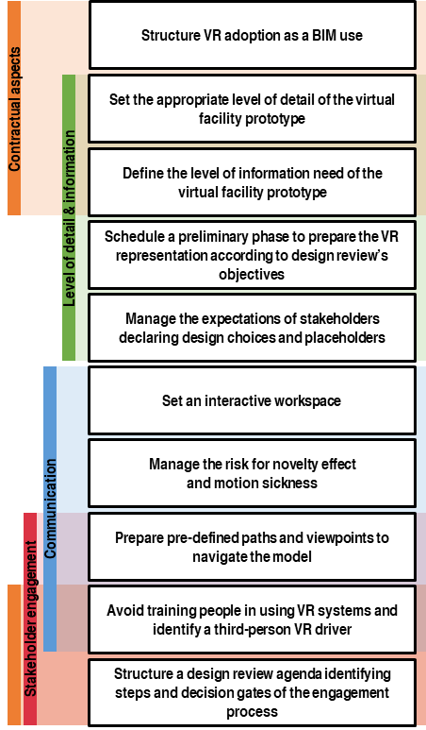
Figure 8: Framework of procedural considerations colour-coded based on the relevant categories
The growing interest of the construction sector towards virtual reality systems and interactive workspaces requires further research in order to effectively address technology investments and integration of those systems into design processes. In particular, a lack of understanding in relation to the added value, if any, generated by VR adoption exists. Moreover, no guidelines are available to lead users to the selection of the most appropriate VR system based on their needs and expected user performance and interaction with the virtual facility prototype according to VR purposes and related uses. Furthermore, future research works should investigate how cognitive processes in collaborative activities, such as design review meetings when multiple stakeholders are involved, change because of the adoption of virtual reality systems.
Finally, additional research should be related to the contractual aspects of VR adoption in design review meetings; the different types of design processes (e.g., user-centred design, participatory design) should be also taken into account.

Acknowledgments
The Construction Technology Institute of the National Research Council of Italy funded the PhD scholarship of one of the authors. The VR system and the visualization package that was used to prepare the VR representation were provided by TeamSystem Spa. The authors would like to acknowledge Barbara Angi and Lavinia C. Tagliabue for their contribution in the organisation of the interviews. The authors would like to mention Stefano Libretti, Carlo Cominelli and Marco Gelfi who developed the design proposal and set the immersive virtual environment.

References
Aksenova, G., Kiviniemi, A., Kocaturk, T., & Lejeune, A. (2018). From Finnish AEC knowledge ecosystem to business ecosystem: lessons learned from the national deployment of BIM. Construction Management and Economics, 1-19.
Balakrishnan, B., Kalisperis, L. N., Muramoto, K., & Otto, G. H. (2006). Multimodal virtual reality environment for architectural design (re) presentation. Proceedings of the 11th International Conference on Computer Aided Architectural Design Research in Asia, 513-519.
Bordegoni, M., & Rizzi, C. (2011). Innovation in product design: from CAD to virtual prototyping, Springer.
BS 8536-1:2015 - Briefing for design and construction. Part 1: Code of practice for facilities management (Buildings infrastructure).
Bullinger, H. J., Bauer, W., Wenzel, G., and Blach, R. (2010). Towards User centred design (UCD) in architecture based on immersive virtual environments, Computers in Industry, 61(4), 372–379.
Castronovo, F., Nikolic, D., Liu, Y. & Messner, J. I. (2013). An evaluation of immersive virtual reality systems for design reviews. In: N. Dawood and M. Kassem (Eds.), Proceedings of the 13th International Conference on Construction Applications of Virtual Reality, 30-31.
Khashe, S., Becerik-Gerber, B., Lucas, G., & Gratch, J. (2018). Persuasive Effects of Immersion in Virtual Environments for Measuring Pro-Environmental Behaviors, 35th International Symposium on Automation and Robotics in Construction, 22-25.
Kreider, R. G. (2013). An ontology of the uses of building information modeling. PhD Dissertation, Penn State University.
Lather, J., Leicht, R., & Messner, J. (2018). Engaging with BIM: Interactive Workspaces in Facility Design and Construction. In Construction Research Congress 2018, 765-775.
Liu, Y. (2017). Evaluating Design Review meetings and the Use of Virtual Reality for Post-Occupancy Analysis. PhD Dissertation, Penn State University
Liu, Y., Lather, J., & Messner, J. (2014). Virtual Reality to Support the Integrated Design Process: A Retrofit Case Study. In Computing in Civil and Building Engineering (2014) (pp. 801-808)
Mansouri, S., & Akhavian, R. The Status Quo and Future Potentials of Data Analytics in AEC/FM: A Quantitative Analysis of Academic Research and Industry Outlook. In Construction Research Congress 2018, 90-100.
Mastrolembo Ventura S. & Castronovo F., (2018). An Agenda for Implementing Semi-Immersive Virtual Reality in Design Meetings Involving Clients and End-Users, ECPPM 2018 - 12th European Conference on Product & Process Modelling, 12-14.
Mastrolembo Ventura S., Hilfert T., Archetti M., Rizzi M., Spezia A., Tagliabue L.C., Oliveri E. & Ciribini A., (2018). Evaluation of Building Use Scenarios by Crowd Simulations and Immersive Virtual Environments: a Case Study, ISARC 2018 - 35th International Symposium on Automation and Robotics in Construction.
Paes, D., Arantes, E., & Irizarry, J. (2017). Immersive environment for improving the understanding of architectural 3D models: Comparing user spatial perception between immersive and traditional virtual reality systems. Automation in Construction, 84, 292-303.
Shiratuddin, M. F., Thabet, W., & Bowman, D. (2004). Evaluating the effectiveness of virtual environment displays for reviewing construction 3D models. In Proceedings of the 4th International Conference on Construction Applications of Virtual Reality, 87–98.
Suwal, S., & Singh, V. (2018). Assessing students’ sentiments towards the use of a Building Information Modelling (BIM) learning platform in a construction project management course. European Journal of Engineering Education, 43(4), 492-506.
Tiainen, T., Ellman, A., & Kaapu, T. (2014). Virtual prototypes reveal more development ideas: comparison between customers' evaluation of virtual and physical prototypes: This paper argues that virtual prototypes are better than physical prototypes for consumers-involved product development. Virtual and Physical Prototyping, 9(3), 169-180.
Tseng, K. C., & Huang, P. H. (2017). A systematic review of the potential application of virtual reality within a user pre-occupancy evaluation. In International Conference on Universal Access in Human-Computer Interaction, 612-20.
Tutt D. and Harty C. (2013). Journeys through the CAVE: the use of 3D immersive environments for client engagement practices in hospital design. In Proceedings of the 29th Annual ARCOM Conference, 111-121.
Van den Berg, M., Hartmann, T., & de Graaf, R. (2017). Supporting design reviews with pre-meeting virtual reality environments. Journal of Information Technology in Construction (ITcon), 22(16), 305-321.
Whyte, J. and Nikolić, D. (2018). Virtual reality and the built environment, 2nd Edition, Routledge

